Researcher spotlight

There are a number of ways that AgriFutures Australia presents its research and development investment to levy payers and key stakeholders. One approach is to highlight the people behind the research and we would like to profile you and your research in a “Research Spotlight".

Your “Researcher Spotlight” may be used in a number of ways. This includes, but may not be limited to, industry, and the agricultural community at large, via our industry update emails, corporate newsletter, website and social media channels, inclusion on the AgriFutures Australia website, corporate newsletter, via social media. An example from our website and corporate newsletter follows.

Could you kindly complete the questions below and please supply a photograph of you to accompany your “Researcher Spotlight”. Please ensure the photo is high-resolution and landscape. Here are some tips on how to take great photos using just your smartphone.

Questions

1. In three sentences or less, briefly outline the project (50-100 words)
2. Why is this research project important? (150-200 words)
3. Why did you get involved in the project? (100 words)
4. How will this research benefit the X industry? Are there any learnings beyond this industry? (150-200 words)
5. What’s the best piece of professional/career advice you’ve ever been given? (50-100 words)
6. What have you learned about your industry from the growers/producers you have been involved with? (50-100 words)

Some logistics

- Please confirm your AgriFutures Australia project number: PRJ-XX
- So we can tag you in any social media posts could you please confirm any relevant social media handles (Linkedin, Twitter, Facebook and Instagram). Please include any personal (if appropriate) and your organization/research institution.

- Linkedin
- Twitter
- Facebook
- Instagram

- Please provide the relevant contact details for your communications contact/team. AgriFutures Australia will seek approval (if required) from the relevant contact prior to distribution.

Example

https://www.agrifutures.com.au/news/precision-weed-researcher-spotlight/

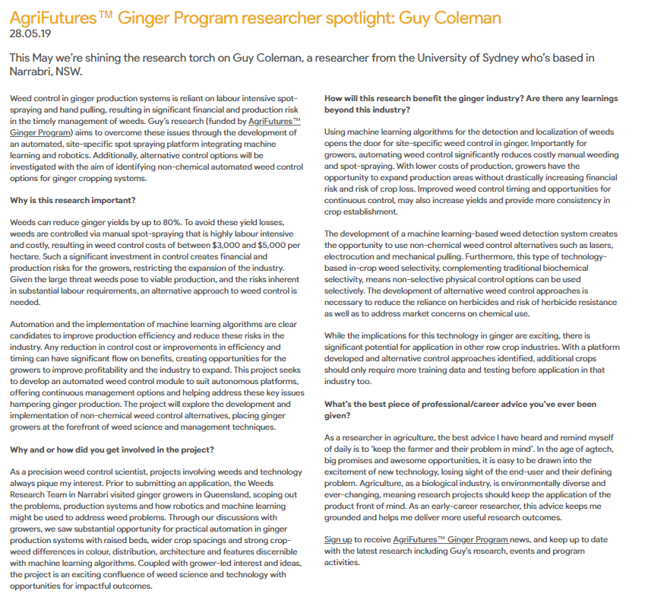

AgriFutures™ Ginger Program researcher spotlight: Guy Coleman
28.05.19
This May we’re shining the research torch on Guy Coleman, a researcher from the University of Sydney who’s based in Narrabri, NSW.

Weed control in ginger production systems is reliant on labour intensive spot-spraying and hand pulling, resulting in significant financial and production risk in the timely management of weeds. Guy’s research (funded by AgriFutures™ Ginger Program) aims to overcome these issues through the development of an automated, site-specific spot spraying platform integrating machine learning and robotics. Additionally, alternative control options will be investigated with the aim of identifying non-chemical automated weed control options for ginger cropping systems.

Why is this research important?
Weeds can reduce ginger yields by up to 80%. To avoid these yield losses, weeds are controlled via manual spot-spraying that is highly labour intensive and costly, resulting in weed control costs of between $3,000 and $5,000 per hectare. Such a significant investment in control creates financial and production risks for the growers, restricting the expansion of the industry. Given the large threat weeds pose to viable production, and the risks inherent in substantial labour requirements, an alternative approach to weed control is needed.
Automation and the implementation of machine learning algorithms are clear candidates to improve production efficiency and reduce these risks in the industry. Any reduction in control cost or improvements in efficiency and timing can have significant flow on benefits, creating opportunities for the growers to improve profitability and the industry to expand. This project seeks to develop an automated weed control module to suit autonomous platforms, offering continuous management options and helping address these key issues hampering ginger production. The project will explore the development and implementation of non-chemical weed control alternatives, placing ginger growers at the forefront of weed science and management techniques.
Why and or how did you get involved in the project?
As a precision weed control scientist, projects involving weeds and technology always pique my interest. Prior to submitting an application, the Weeds Research Team in Narrabri visited ginger growers in Queensland, scoping out the problems, production systems and how robotics and machine learning might be used to address weed problems. Through our discussions with growers, we saw substantial opportunity for practical automation in ginger production systems with raised beds, wider crop spacings and strong crop-weed differences in colour, distribution, architecture and features discernible with machine learning algorithms. Coupled with grower-led interest and ideas, the project is an exciting confluence of weed science and technology with opportunities for impactful outcomes.
How will this research benefit the ginger industry? Are there any learnings beyond this industry?
Using machine learning algorithms for the detection and localization of weeds opens the door for site-specific weed control in ginger. Importantly for growers, automating weed control significantly reduces costly manual weeding and spot-spraying. With lower costs of production, growers have the opportunity to expand production areas without drastically increasing financial risk and risk of crop loss. Improved weed control timing and opportunities for continuous control, may also increase yields and provide more consistency in crop establishment.
The development of a machine learning-based weed detection system creates the opportunity to use non-chemical weed control alternatives such as lasers, electrocution and mechanical pulling. Furthermore, this type of technology-based in-crop weed selectivity, complementing traditional biochemical selectivity, means non-selective physical control options can be used selectively. The development of alternative weed control approaches is necessary to reduce the reliance on herbicides and risk of herbicide resistance as well as to address market concerns on chemical use.
While the implications for this technology in ginger are exciting, there is significant potential for application in other row crop industries. With a platform developed and alternative control approaches identified, additional crops should only require more training data and testing before application in that industry too.
What’s the best piece of professional/career advice you’ve ever been given?
As a researcher in agriculture, the best advice I have heard and remind myself of daily is to ‘keep the farmer and their problem in mind’. In the age of agtech, big promises and awesome opportunities, it is easy to be drawn into the excitement of new technology, losing sight of the end-user and their defining problem. Agriculture, as a biological industry, is environmentally diverse and ever-changing, meaning research projects should keep the application of the product front of mind. As an early-career researcher, this advice keeps me grounded and helps me deliver more useful research outcomes.
Sign up to receive AgriFutures™ Ginger Program news, and keep up to date with the latest research including Guy’s research, events and program activities.

